K.V.G. COLLEGE OF ENGINEERING
Kurunjibhag, Sullia, D.K.-574 327, Karnataka, INDIA
E-mail: office@kvgengg.com website: www.kvgengg.com

Department of Physics

FACULTY PROFILE

Name of the Faculty |  | HAREESHA K |  |  |  | 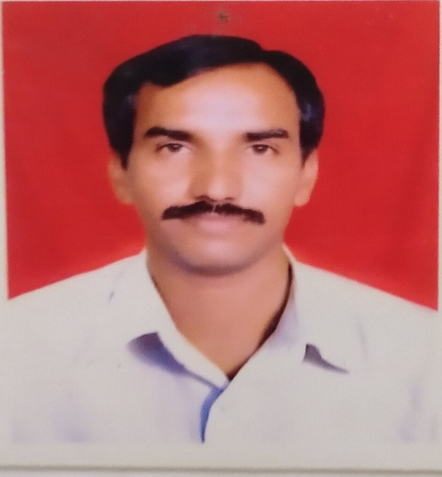
Designation |  | Foreman
Contact Number
 |  | Mobil: +91 9449334382
E-mail ID |  | hareeshk@yahoo.com
- Educational Qualification

Qualification | Specialization |  | Year of Passing |  | College &Board
B Sc.  B Ed | Physics, Chemistry, Mathematics.  Physics, Mathematics |  | 1989  1991 |  | St Philomena College Puttur  Govt College Mangalore
- Work Experience
Lab Instructor |  |  |  | Sr. Lab Instructor |  |  | FF Foreman
13+Year Experience |  |  |  | 7+ Year Experience |  |  | F10+ Year Experience
- Date of Joining to the College
02nd September 1991

- In-House Experience
Designation |  |  | Duration |  |  |  | Department
 |  |  | From |  | To
Lab Instructor |  |  | 02-09-1991 |  | 05-12-2004 |  | PHYSICS
Senior Instructor |  |  | 06-12-2004 |  | 26-02-2012 |  | PHYSICS
Foreman |  |  | 27-02-2012 |  | Till date |  | PHYSICS
- Workshops / Short-termCourse Attended

SL. No. | Workshop Title |  |  | Place |  |  |  | Date & Year
 | Best Practice for Computer Lab Management |  |  | KVGCE, CS Dept, Sullia |  |  |  | 12th & 13 Oct, 2012
 | Workshop on Maintenance of Lab Equipment |  |  | KVGCE, Mechanical Dept |  |  |  | 30th Jan2013
- Responsibilities Taken in College Level
Event |  | Positions |  |  |  | Duration
 |  |  |  |  |  | From |  | From
State Level Paper Presentation & Quiz Convention |  | Member-Food committee |  |  |  | 2006 |  | ----
Annual Sports Meet |  | Officials for events |  |  |  | 05-03--11 |  | -----
Farewell Function |  | Coordinator |  |  |  | 21-05-2012 |  | 2017
Ayudha pooja |  | Pooja committee |  |  |  | 2018 |  | Till the date
K.V.G. Science Talent Hunt Programme |  | Food Committee |  |  |  | 15-12-2018 |  | ------
K.V.G .Science Talent Hunt Programme |  | FoodCommittee |  |  |  | 09-11-2019 |  | ------
Medical and First Aid Facilities Cell |  | In-charge for Physics department |  |  |  | 2013 |  | Till Date
- Participation details in the Department level activities
- Awards / Recognition / Achievements/ Others
- Participated and won the prize in chess competition at KVGCE.
.
Mr.HAREESHA K ,DEPARTMENT OF PHYSICS., KVGCE, SULLIA, D.K-574327.
Reach me at hareeshk@yahoo.com

